Software development life cycle (SDLC):

Software development life cycle (SDLC) is a structured process that is used to design, develop, and test good-quality software.

Stage-1: Planning and Requirement Analysis

Stage-2: Defining Requirements : all the requirements for the target software are specified. These requirements get approval from customers, market analysts, and stakeholders.

Stage-3: Designing Architecture :software designers to come up with the best architecture for the software

Stage-4: Developing Product : the fundamental development of the product starts. For this, developers use a specific programming code as per the design

Stage-5: Product Testing and Integration : testing of the software is necessary to ensure its smooth execution.

Stage 6: Deployment and Maintenance of Products :After detailed testing, the conclusive product is released in phases as per the organization’s strategy. Then it is tested in a real industrial environment.

Waterfall Model

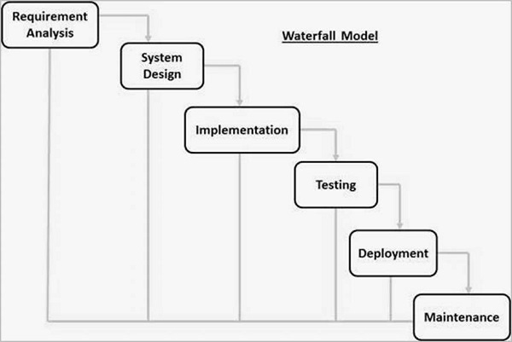

Agile Model

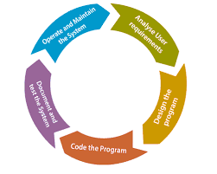

**Spiral Model**

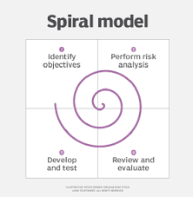

### ****V-Shaped Model****

